Tab 1
Milestone 3 Deliverable
Dori Fu, Rhea Nayar, Fatema Jaynab

Part 1: Methodology
Changes from Milestone 2
In milestone 3, we extend our Milestone 2 pipeline by introducing chain-of-thought (CoT) prompting and evaluating our models on a more realistic dataset. While Milestone 2 focused on comparing zero-shot and few-shot prompting on Financial PhraseBank, our updated approach investigates whether explicitly prompting the model to reason before predicting improves classification accuracy and reduces systematic errors, particularly the tendency to misclassify neutral statements as positive. In addition, we incorporate the FiQA dataset, which contains more informal and noisy financial text, to test the generalizability of our approach beyond a clean benchmark. These additions allow us to move from controlled evaluation toward assessing real world applicability and as well as our sentiment classification pipeline.

Models and Tools Applied
We extend our Milestone 2 setup by incorporating CoT prompting and evaluating the pipeline on a more realistic dataset. The core models remain consistent( TF0iDF+ Logistic regression, LLM zero-shot, LLM few shot) to allow direct comparison, with an additional prompting strategy introduced:
- LLM Chain-of-Thought (GPT-4-mini): We extend the few-shot setup by prompting the model to explicitly reason about each sentence before producing a final classification. The model first generates a short explanation of the sentiment and then outputs the label in structured JSON format. This approach is designed to reduce systematic misclassification errors observed in earlier stages, particularly neutral sentences being labeled as positive.
- Finsentinel System Integration: The finSentinel pipeline integrates data input, model inference, and prediction handling into a unified system. It enables sentiment classification beyond controlled database by processing real-world financial text inputs through the LLM-based pipeline
- Web Application (FinSentinel) : A financial risk intelligence web application (FinSentinel) was developed to analyze financial headlines and market news in real time. The system integrates prompt-engineered LLM pipelines, retrieval-augmented generation (RAG), and structured JSON outputs to classify sentiment, identify financial risk types, estimate severity, and determine market impact. Users can analyze live Yahoo Finance headlines, custom text inputs, and benchmark datasets such as FiQA and Financial PhraseBank through an interactive interface. The frontend communicates with the backend inference pipeline, which retrieves contextual information, processes prompts through LLM models, and returns transparent structured outputs including reasoning traces and confidence scores. This component demonstrates the practical deployment of an end-to-end financial NLP and risk analysis system in a user-facing environment.
Pipelines
The overall pipeline follows the same structure as Milestone 2, with extensions to support chain-of-thought prompting and evaluation on a new dataset.
- Preprocessing: We use the Financial PhraseBank (AllAgree subset) and the FiQA dataset. Financial PhraseBank provides clean, professionally annotated sentences, while FiQA introduces more informal noisy text. Both datasets are parsed and formatted into input-output pairs without additional preprocessing, as they are already well structured.
- Feature representation: For the TF-IDF baseline, text is converted into numerical vectors using unigram and bigram features. For LLM-based models, raw text is embedded implicitly through the models internal tokenization and representations.
- Model Inference: The model supports multiple inference models including TF-IDF+Logistic Regression (trained baseline), LLM zero-shot prompting, LLM few-shot prompting, LLM chain-of-thought prompting.
- Prediction output: ALl lLLM outputs are formatted into structured JSON containing the predicted sentiment, For chain-of-thought prompting, the reasoning step is generated but only the final label is used for evaluation
- Evaluation: Predictions are compared against ground truth labels using accuracy, precision, recall, macro F1-Score, and confusion matrices. Evaluation is performed on both financial phraseBank and FiQA to assess generalization
- Application Layer (Website integration): The pipeline is deployed through the FinSentinel web application, where user inputs and live financial headlines are processed in real time. The backend uses prompt-engineered LLMs and RAG retrieval to generate structured outputs including sentiment, risk type, severity, market impact, confidence, and reasoning. This layer connects the modeling pipeline to a practical user-facing deployment.

Part 2: Results
EDA Visualization
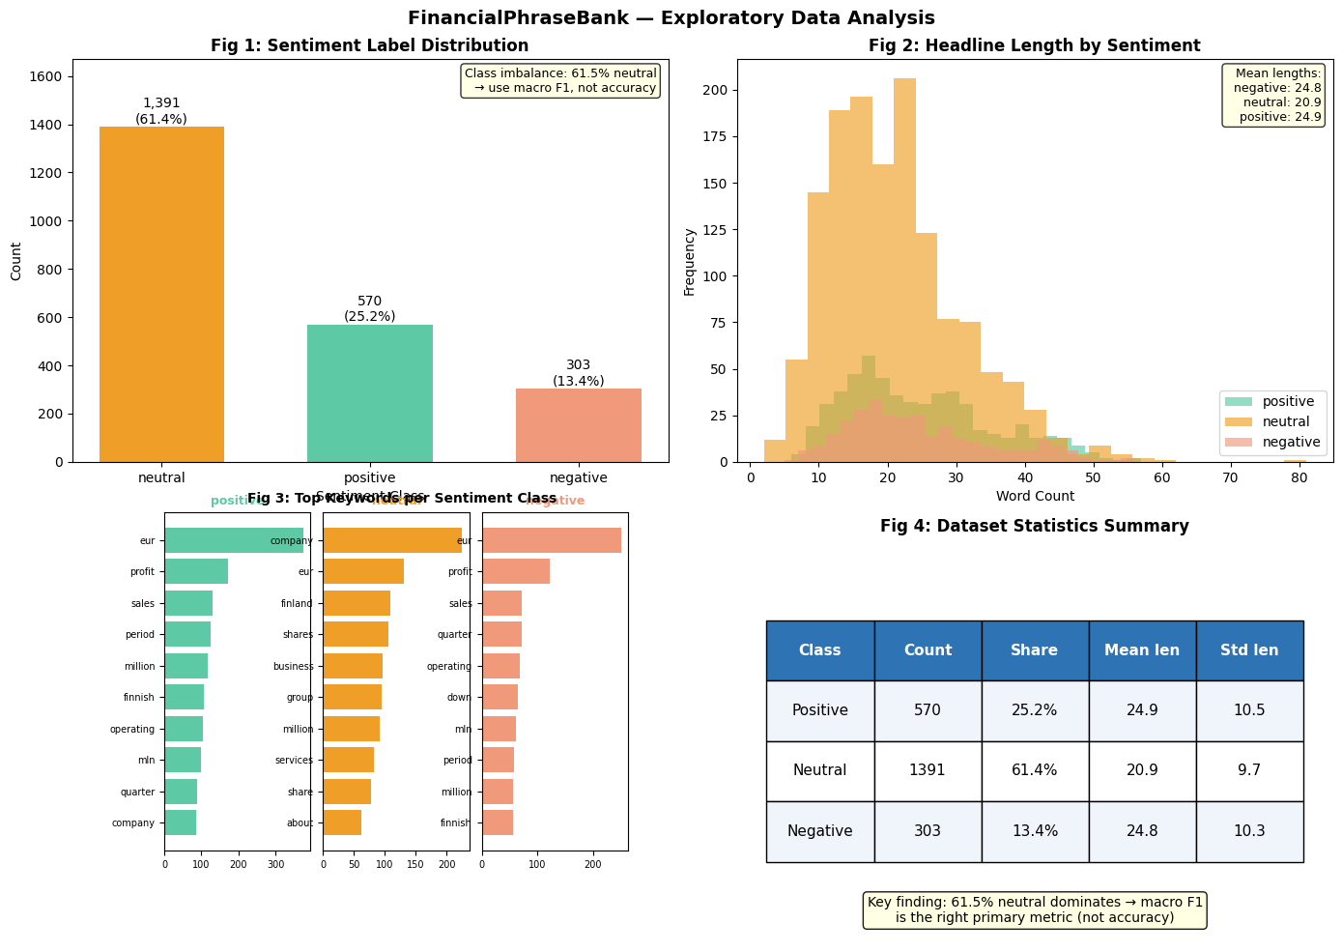
The Financial Phrasebank dataset exhibits a clear class imbalance, with neutral labels dominating (61.4%) followed by positive (25.2%) and negative (13.4%), making macro F1 the appropriate evaluation metric over accuracy. Headline length distributions are similar across classes, indicating that sentiment is not driven by length but by content. Keyword analysis shows distinct lexical patterns: positive headlines contain terms like “profit”, “increase”, and “growth”, while negative headlines include “loss”, “decrease”, and “down”. Neutral headlines are dominated by general terms such as “company”, “ sales”, and “reported”, reflecting factual reporting. Overall the dataset contains strong lexical signals but also highlights why distinguishing neutral vs positive sentiment is the most challenging aspect of the task.

LoRA Training Results
The FinBert and LoRA model achieves a strong performance with 98.5% accuracy and a macro score of .978, which outperforms zero shot-few-shot and chain-of-thought prompting. It shows balanced precision and recall across all classes, including a high recall for positive sentiment, indicating it captures subtle signals without the neutral bias observed in CoT. In addition to performance, LoRA is highly efficient, training only .27% of the model parameters while keeping the base model frozen. Overall, while prompting methods are flexible, LorA fine-tuning provides more accurate and consistent predictions, making it better suited for high-reliability financial sentiment tasks.

DistilBERT Student Training Curve
We Also tested knowledge distillation by using the larger LLM-based agent as a teacher to generate soft labels for 500 training examples, then training a smaller DistilBERT student model using MSE loss over the full probability distribution. The motivation was to reduce latency and cost. However, the distilled student performed worse than the stronger models, achieving 78.4% accuracy and only .539 macro F1. While it performs well on the neutral class and reasonably on positive sentiment, it struggles heavily with the negative class, with only .02 recall. This suggests that the student model learned the majority and easier sentiment patterns but failed to capture minority-class distinctions. Overall, distillation improves deployment efficiency but sacrifices too much accuracy in its current form, making it unsuitable as the primary model without more training data, better teacher labels, or class-balancing improvements.

Full Benchmark Table - Financial PhraseBank
The financial PhraseBank benchmark reveals clear performance differences across model tiers. FinBert + LoRA achieves best overall results (98.5 accuracy, .978 macro F1), outperforming both traditional ML and prompting-based methods while maintainably low latency and zero API cost. GPT-4o-mini few-shot reaches comparable accuracy but is significantly slower (1.2s) and incurs cost, limiting practicality for real time use. Traditional methods like TF-IDF + Logistic Regression perform reasonably well, with a macro F1 of .759, but lack contextual understanding. More complex approaches like CoT, RAG + CoT, and ReAct agent do not improve performance and in some cases degrade it, suggesting additional reasoning or system complexity is unnecessary for this structured dataset. Finally, the DistilBer student highlights the efficiency-accuracy trade-off, achieving much lower performance despite minimal latency. Overall, FinBert + LoRA provides the best balance of accuracy, efficiency, and cost, making it the most suitable for deployment on Financial PhraseBank.

Confusion Matrices
The confusion matrices reveal distinct error patterns across models. TF-IDF + Logistic Regression performs reasonably well but shows confusion between positive and neutral classes, reflecting its reliance on surface-level keywords. FinBERT zero-shot demonstrates the strongest performance, with near-perfect classification across all classes and minimal misclassification, indicating strong contextual understanding of financial language. In contrast, GPT-4o-mini zero-shot exhibits a clear bias toward neutral predictions, frequently misclassifying positive examples as neutral, which lowers its macro F1 score. The RAG + CoT model improves over zero-shot GPT by reducing some of these errors, particularly for the positive class, but still shows residual confusion between neutral and positive categories. Overall, the matrices highlight that more advanced models reduce misclassification, but errors are consistently concentrated in distinguishing neutral from positive sentiment, which remains the most challenging boundary in financial text.

Model Performance Dashboard
The FinSentinel dashboard shows clear trade-offs between performance and efficiency. FinBERT + LoRA and few shot prompting achieve the highest macro F1(0.978) while simpler models perform moderately and the distilled student agent models lag behind. The DistilBERT training curve shows steady improvement but plateaus at a lower performance level (.54). The accuracy-latency plot highlights that FinBERT + LoRA offers near top accuracy with much lower latency (50 ms), making it the best balance for deployment, while GPT-based methods are slower and the distilled model sacrifices accuracy for speed.

FiQA Cross-Dataset Results
Evaluation on the FiQA dataset shows a significant drop in performance, with accuracy falling to 10% and macro f1 to .08. The model predicts the neutral class (recall = 1.00) while failing to identify negative sentiment entirely and capturing only a small position of positive examples (recall = .8). This indicates a strong bias toward neutral predictions and a failure to generalize to informal, noisy financial text. Unlike Financial PhraseBank, FiQA contains microblog-style language with abbreviations, slang, and implicit sentiment, which the model struggles to interpret. These results highlight that strong performance on clean, structured datasets does not translate to real-world settings, emphasizing the need for domain adaptation, improved prompting or additional training on noisy data.

McNemar's Test Results
McNemar's test confirms that the improvement from zero-shot to few-shot prompting is drastically significant (p<0.001), while the difference between few-shot and CoT is not significant (p = 0.109). This indicates that few-shot provides a meaningful performance gain, but CoT does not offer a statistically reliable improvement over few -shot. Error analysis further explains the result that out of 29 disagreements, few-shot corrects 27 zero-shot errors while introducing only 2 new mistakes. The dominant zero-shot failure mode is misclassifying positive sentences as neutral (90% of errors) showing a strong neutral bias. Few-shot largely resolves this issue by better capturing positive sentiment signals, leading to improved recall for the positive class. Overall, these results demonstrate that few-shot prompting provides a statically significant and practically meaningful improvement, while coT primarily alters model behavior without yielding consistent performance gains.

Part 3: Analysis
Analysis of FPB CoT
The chain-of-thought (CoT) model achieves strong performance with an accuracy of 93%, performing particularly well on negative and neutral classes with high F1 scores and near-perfect recall. However, for positive sentiment, the model shows high precision but lower recall, indicating a conservative approach where it only assigns positive labels when highly confident. As a result, several positive headlines are misclassified as neutral, reflecting a bias toward neutral predictions. This behavior is likely due to both the cautious reasoning introduced by CoT prompting and the nature of financial language, which often presents information without clear directional sentiment.Further analysis of misclassifications shows that neutral-to-positive errors are rare, with only one such case observed. This confirms that the model does not overestimate positive sentiment but instead underpredicts it.
Overall, large language models perform strongly for financial sentiment classification, significantly outperforming the baseline. Zero-shot prompting already demonstrates strong performance, while few-shot prompting achieves the best results by improving sensitivity to domain-specific cues. Although CoT maintains high accuracy and improves interpretability, it introduces a trade-off by reducing recall for positive sentiment. These results highlight the importance of prompt design in balancing precision and recall, particularly in nuanced financial contexts.

Part 4: Conclusions - Strengths, weaknesses, limitations, future work.
Strengths
This project demonstrates that large language models and domain-adapted transformers are highly effective for financial sentiment classification. Models such as FinBert + LoRA and few-shot prompting achieve strong performance, with strong macro f1 scores and balanced class prediction. The inclusion of multiple modeling approaches of traditional ML, prompting, fine-tuning, and distillation provides a comprehensive comparison across accuracy, latency and cost. Additionally the development of the FinSentinel web application shows the practical applicability of the pipeline in a real-world, user-facing setting.

Weaknesses and Limitations
Despite strong performance on Financial PhraseBank, results do not generalize well to FiQA, where performance drops significantly due to noisy, informal language. This highlights a key limitation that models trained or evaluated on clean datasets may not perform reliably in real-world scenarios. Additionally, prompting-based methods introduce latency and cost constraints, making them less suitable for real-time deployment. While LoRA fine tuning performs well, it still depends on labeled data, and the DistilBERT student model shows that aggressive compression can significantly reduce accuracy, particularly for minority classes

Future Work
Future work should focus on improving generalization to real world data by incorporating noisy datasets like FiQA during training or applying domain adaptation techniques. Enhancing prompt design or combining prompting with fine-tuning could further improve performance. Additional improvements could include class balancing strategies to better capture minority classes, particularly negative sentiment. From a systems perspective, integrating retrieval more effectively or refining lightweight models could help balance accuracy and efficiency. Finally, extending the FinSentinel application with live data sources and user interaction features would further demonstrate real-world deployment potential.

Part 5: Workflow
The project followed a structured, iterative workflow from data exploration to deployment. We began with exploratory data analysis (EDA on the financial PhraseBank dataset to understand class distribution, text characteristics and key lexical patterns. Based on these insights, we implemented a baseline model to establish a performance benchmark. We then expanded to LLM-based approaches, including zero-shot, few-shot, and CoT prompting, to evaluate how prompt design impacts performance. We also developed a supervised fine-tuning pipeline using FinBert with LoRA, which provided the strongest performance while maintaining efficiency. To explore scalability, we also implemented a DistilBERT student model via knowledge distillation, trading accuracy for reduced latency. Next we conducted comprehensive evaluations and statistical analysis, including confusion matrices, McNemar’s test, and cross dataset validation on FiQA to assess generalization. Finally, we integrated the best-performing models into the FinSentinel pipeline and deployed a web-based application for real-time financial news analysis. The system processes user-provided or live financial headlines and returns structured outputs including sentiment, risk type, severity, and market impact. This end-to-end workflow demonstrates both strong analytical performance and practical deployment capability.

